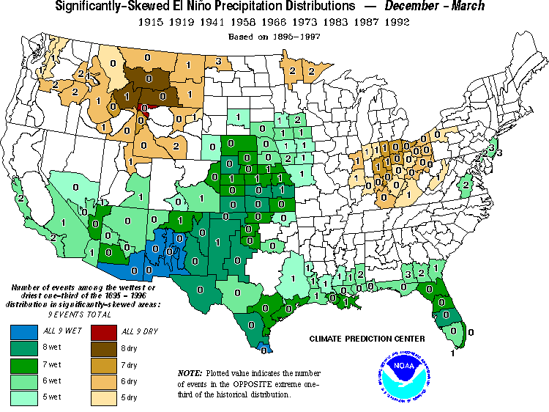
Figure 1: Map showing the number of historically very strong El Nino events during the past century which were associated with significant winter precipitation anomalies. Note that south central New Mexico falls within the region of most robust precipitation increase in association with warm events.

