**Supplementary Information for Record Temperature Streak Bears Anthropogenic Fingerprint**

Michael E. Mann1

Sonya K. Miller1

Stefan Rahmstorf2

Byron A. Steinman3

Martin Tingley4

1Department of Meteorology, Pennsylvania State University2Earth System Analysis, Potsdam Institute for Climate Impact Research3Department of Earth and Environmental Sciences and Large Lakes Observatory, University of Minnesota Duluth4Departments of Meteorology and Statistics, Pennsylvania State University

revised for *Geophysical Research Letters* 7/17

**Macintosh HD:Users:Byron:Google Drive:Research:Meetings / Manuscripts / Talks:2017 Mann GRL temp prob:revision:FigureS1.pdf**

**Figure S1.** Autocorrelation (blue) for innovation series from statistical model fits along with two-sided 95% significance levels (dashed red curves) based on (a) NH GISTEMP observations and *corrected* CMIP5 multimodel series, (b) NH HadCRUT4 observations and *uncorrected* CMIP5 multimodel series, (c) As ‘a’ but for global mean, (d) As ‘b’ but for global mean. Results for both NH and global mean temperature for both these and the other two cases (GISTEMP observations and uncorrected CMIP5 model series, HadCRUT4 series and corrected CMIP5 model series) are available in the supplementary online archive.

**Macintosh HD:Users:Byron:Google Drive:Research:Meetings / Manuscripts / Talks:2017 Mann GRL temp prob:revision:FigureS2.pdf**

**Figure S2.** Probability of three consecutive records as a function of ending year from 1970 through 2016 based on (a) NH GISTEMP observations and *corrected* CMIP5 multimodel series, (b) NH HadCRUT4 observations and *uncorrected* CMIP5 multimodel series, (c) As ‘a’ but for global mean, (d) As ‘b’ but for global mean. Results for both NH and global mean temperature for both these and the other two cases (GISTEMP observations and uncorrected CMIP5 model series, HadCRUT4 series and corrected CMIP5 model series) are available in the supplementary online archive.

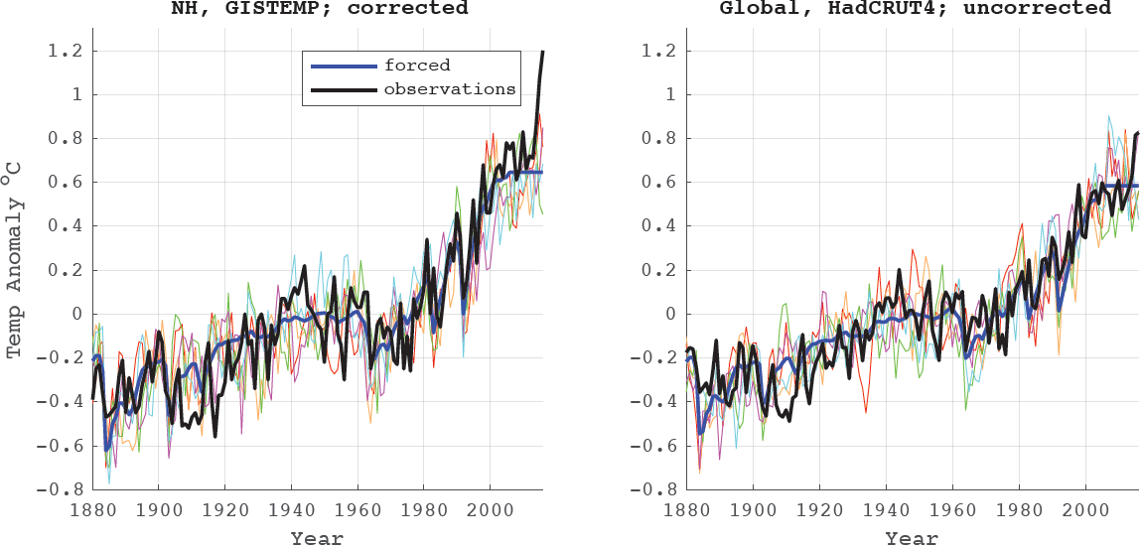

**Figure S3.** Simulated vs. Observed temperatures (1880-2016) based on all-forcing experiments as in Fig 4 of main article, but using persistence for the post-2005 extension of the CMIP5 series. Results are shown for two representative examples: (a) NH mean temperature using GISTEMP observations and *corrected* CMIP5 model series and (b) global mean temperature using HadCRUT4 observations and *uncorrected* CMIP5 multimodel series. Results for all cases are available in the supplementary online archive.

**Table S1**. CMIP5 Climate Model Simulations

|  |  |  |  |  |  |
| --- | --- | --- | --- | --- | --- |
| Model | Number of Realizations | Length of runs (yr) | Start year AD | End Year AD | 1st *and* 2nd aerosol indirect effects |
| *All Forcing Simulations* | | | | | |
| GISS-E2-R | 24 | 156 | 1850 | 2005 | N |
| GISS-E2-H | 17 | 156 | 1850 | 2005 | N |
| CNRM-CM5 | 10 | 156 | 1850 | 2005 | N |
| CSIRO-Mk3.6.0 | 10 | 156 | 1850 | 2005 | Y |
| GFDL-CM2.1 | 10 | 145 | 1861 | 2005 | N |
| HadCM3 | 10 | 146 | 1860 | 2005 | N |
| CCSM4 | 6 | 156 | 1850 | 2005 | N |
| IPSL-CM5A-LR | 6 | 156 | 1850 | 2005 | N |
| CanESM2 | 5 | 156 | 1850 | 2005 | N |
| GFDL-CM3* | 5 | 146 | 1860 | 2005 | Y |
| HadGEM2-ES | 5 | 146 | 1860 | 2005 | Y |
| MIROC5 | 5 | 163 | 1850 | 2012 | Y |
| MRI-CGCM3 | 4 | 156 | 1850 | 2005 | Y |
| ACCESS1.3 | 3 | 156 | 1850 | 2005 | Y |
| bcc-csm1-1 | 3 | 163 | 1850 | 2012 | N |
| bcc-csm1-1m | 3 | 163 | 1850 | 2012 | N |
| CESM1-CAM5 | 3 | 156 | 1850 | 2005 | Y |
| CESM1-FASTCHEM | 3 | 156 | 1850 | 2005 | N |
| FIO-ESM | 3 | 156 | 1850 | 2005 | N |
| IPSL-CM5A-MR | 3 | 156 | 1850 | 2005 | N |
| MPI-ESM-MR** | 3 | 156 | 1850 | 2005 | N |
| MIROC-ESM | 3 | 156 | 1850 | 2005 | Y |
| MPI-ESM-LR* | 3 | 156 | 1850 | 2005 | N |
| NorESM1-M | 3 | 156 | 1850 | 2005 | Y |
| MPI-ESM-P** | 2 | 156 | 1850 | 2005 | N |
| CESM1-WACCM | 1 | 156 | 1850 | 2005 | N |
| HadGEM2-CC | 1 | 146 | 1860 | 2005 | Y |
| HadGEM2-AO** | 1 | 146 | 1860 | 2005 | Y |
| ACCESS1.0 | 1 | 156 | 1850 | 2005 | Y |
| BNU-ESM | 1 | 156 | 1850 | 2005 | N |
| CESM1-BGC | 1 | 156 | 1850 | 2005 | N |
| CMCC-CESM | 1 | 156 | 1850 | 2005 | N |
| CMCC-CM | 1 | 156 | 1850 | 2005 | N |
| CMCC-CMS | 1 | 156 | 1850 | 2005 | N |
| CNRM-CM5-2 | 1 | 156 | 1850 | 2005 | N |
| GFDL-ESM2G | 1 | 145 | 1861 | 2005 | N |
| GFDL-ESM2M | 1 | 145 | 1861 | 2005 | N |
| GISS-E2-H-CC | 1 | 161 | 1850 | 2010 | N |
| GISS-E2-R-CC | 1 | 161 | 1850 | 2010 | N |
| INM-CM4 | 1 | 156 | 1850 | 2005 | N |
| IPSL-CM5B-LR | 1 | 156 | 1850 | 2005 | N |
| MRI-ESM1 | 1 | 155 | 1851 | 2005 | Y |
| FGOALS-g2** | 1 | 156 | 1850 | 2005 | Y |
| NorESM1-ME | 1 | 156 | 1850 | 2005 | Y |
| *Anthropogenic Simulations* | | | | | |
| CNRM-CM5 | 10 | 163 | 1850 | 2012 | N |
| GISS-E2-R | 10 | 163 | 1850 | 2012 | N |
| GISS-E2-H | 6 | 163 | 1850 | 2012 | N |
| CCSM4 | 4 | 156 | 1850 | 2005 | N |
| CESM1-CAM5 | 3 | 156 | 1850 | 2005 | Y |
| GFDL-CM3 | 3 | 146 | 1860 | 2005 | Y |
| IPSL-CM5A-LR | 3 | 156 | 1850 | 2005 | N |
| GFDL-ESM2M | 1 | 145 | 1861 | 2005 | N |
| *One realization from this model was not included in the SAT/SST model means. | | | | | |
| ** This model was not included in the SAT/SST model means.  Dsfsdf  Sdf  Sd  Fdds  Dsfsdfs | | | | | |

**Table S2**. Estimated Likelihoods (in %) – *PERSISTENCE POST-2005 EXTENSION*

|  |  |  |  |  |  |  |  |  |
| --- | --- | --- | --- | --- | --- | --- | --- | --- |
| Corrected Forcings | 20’141 | ‘152 | ‘163 | 1/14 | 2/25 | 3/36 | 1,2,3 (‘16)7 2/25 | ‘16(cond)8 |
| *Natural* |  |  |  |  |  |  |  |  |  |
| NH GISTEMP [AR(1)] | < | < | < | 0.76 | 0.07 | 9·10-3 | 0.002 | 5.2 |  |
| *Anthro* |  |  |  |  |  |  |  |  |
| NH GISTEMP [AR(1)] | 4.4 | 0.05 | 1·10-3 | 7.8 | 2.6 | 1.1 | 0.22 | 15 |
| Uncorrected Forcings |  |  |  |  |  |  |  |  |
| *Natural* |  |  |  |  |  |  |  |  |  |
| Glb HadCRUT4 [AR(1)] | 0.25 | 0.05 | < | 1.4 | 0.25 | 0.05 | 9·10-3 | 6.7 |  |
| *Anthro* |  |  |  |  |  |  |  |  |  |
| Glb HadCRUT4 [AR(1)] | 37 | 2.1 | 1.63 | 8.9 | 3.7 | 2.0 | 0.43 | 19 |