Supplementary Materials

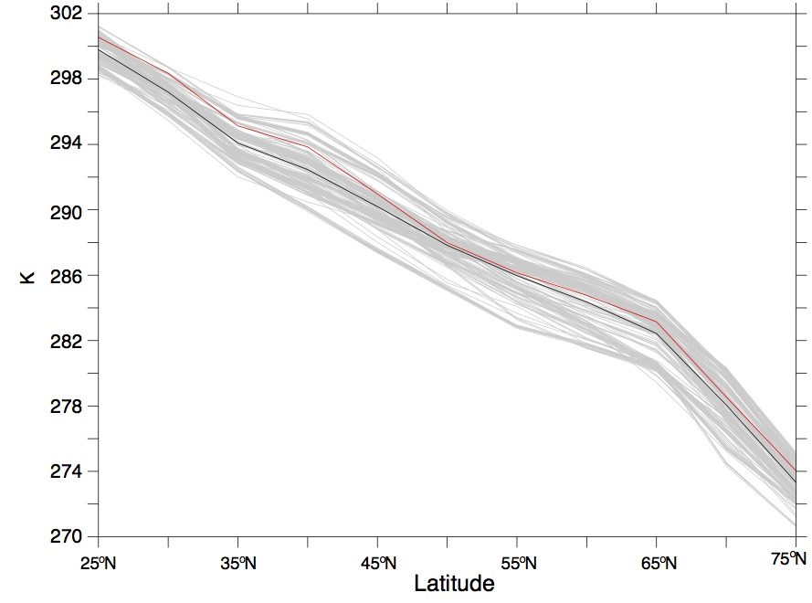
a.
T(φ)

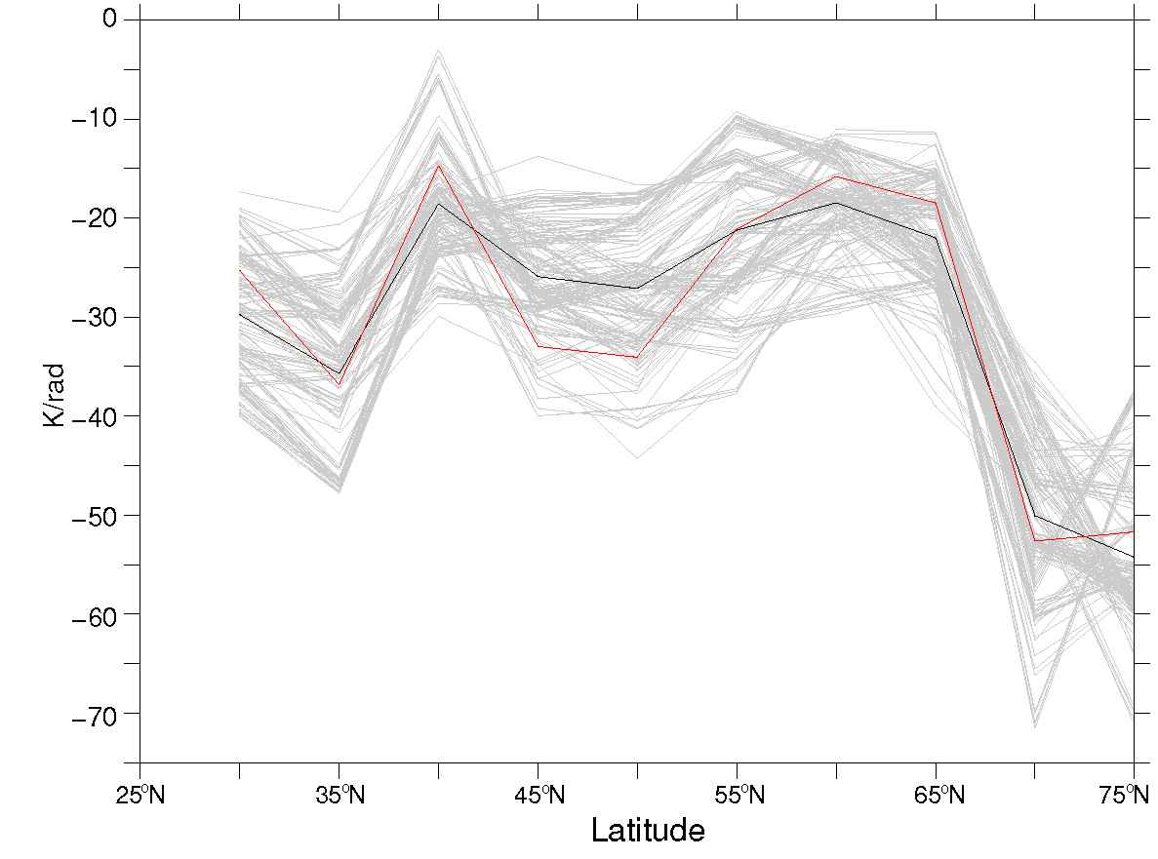
b.

dT(φ)/dφ

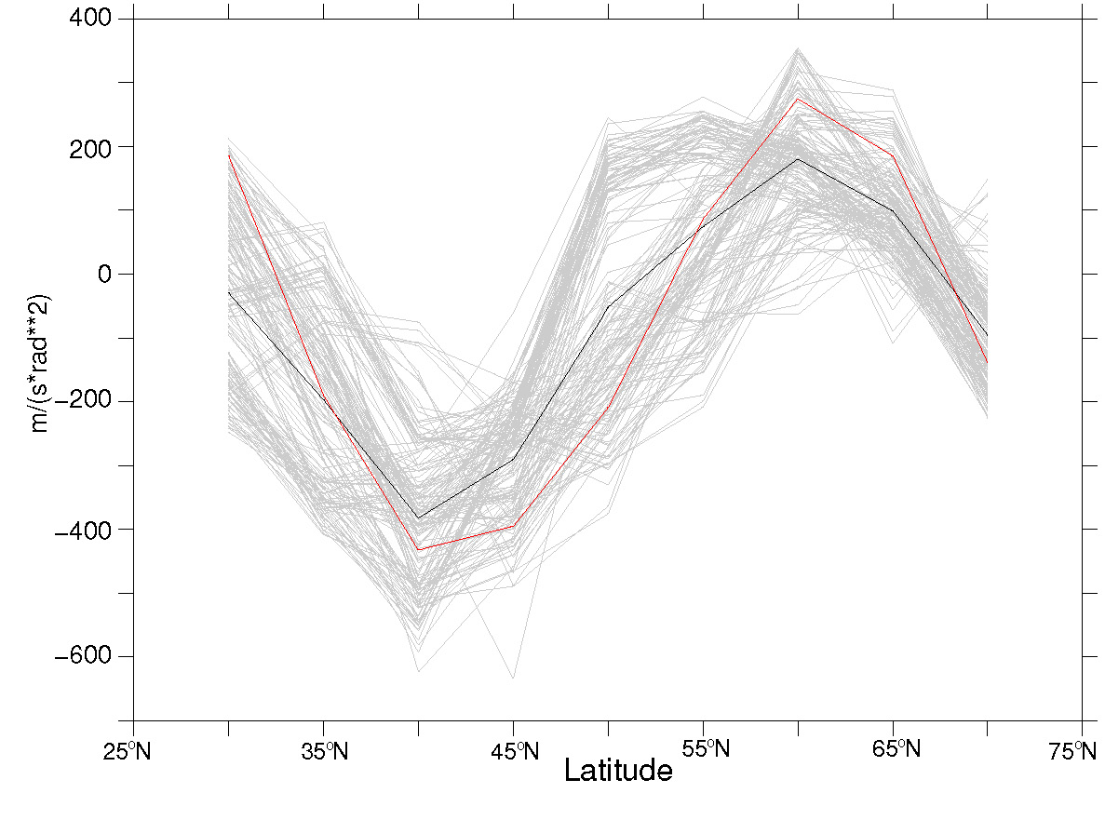
c.
d²u(φ)/dφ²

Figure S1. Latitudinal profiles of (a) T(φ) and (b) dT(φ)/dφ and (c) d²u(φ)/dφ² at 5 degree resolution. Shown in both cases are (grey) the individual realizations of the CMIP5 historical simulations (see “Methods” section of main article) along with the (black) CMIP5 multimodel ensemble mean and (red) ERA reanalysis data (1979-2005). The root-mean-square error of the individual realizations relative to the reanalysis observations is 0.5% in (a) 27% in (b) and 344% in (c).

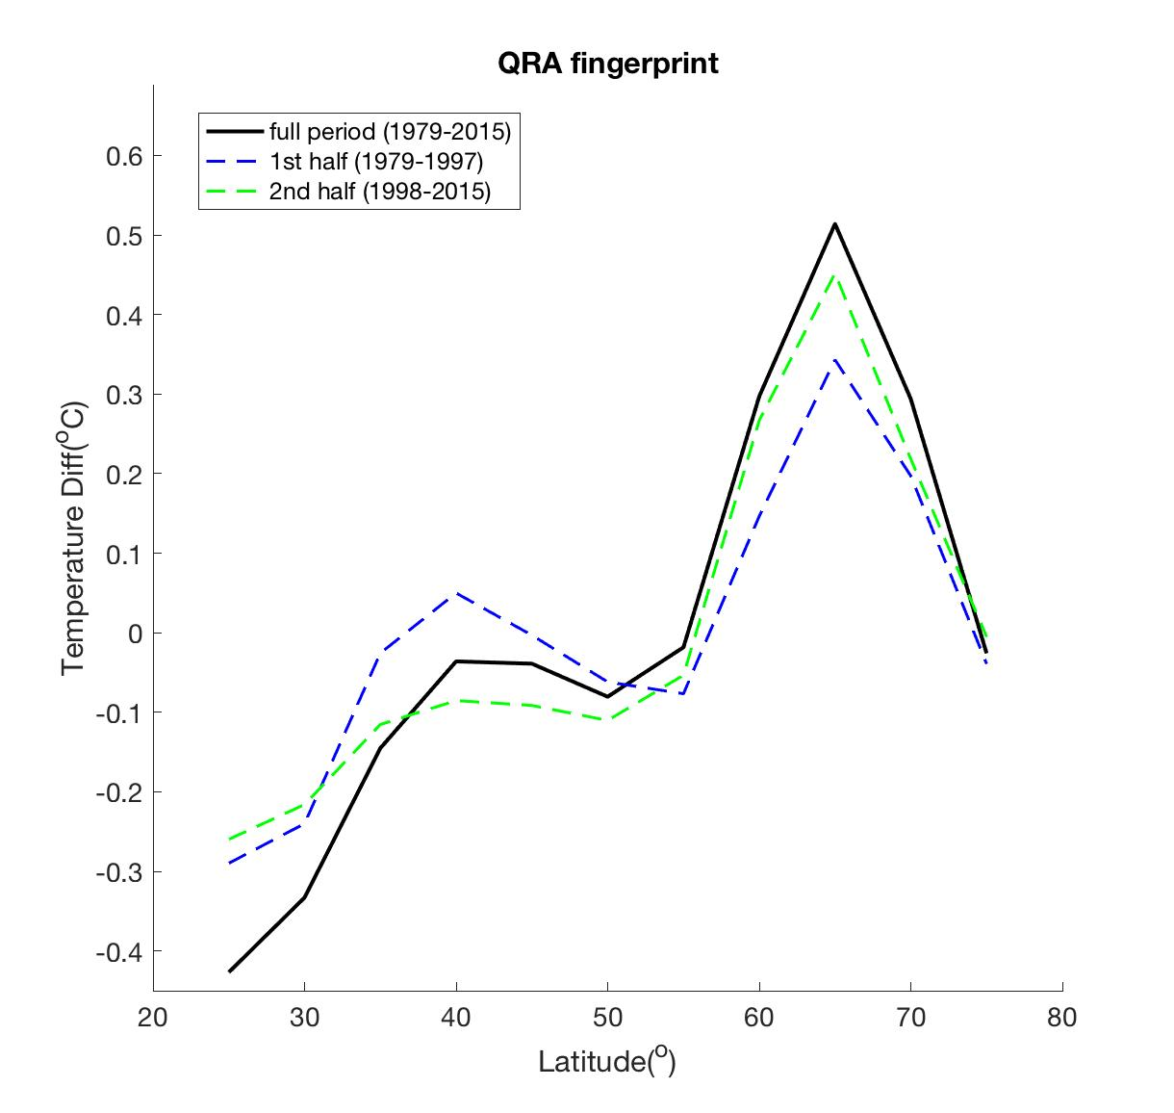

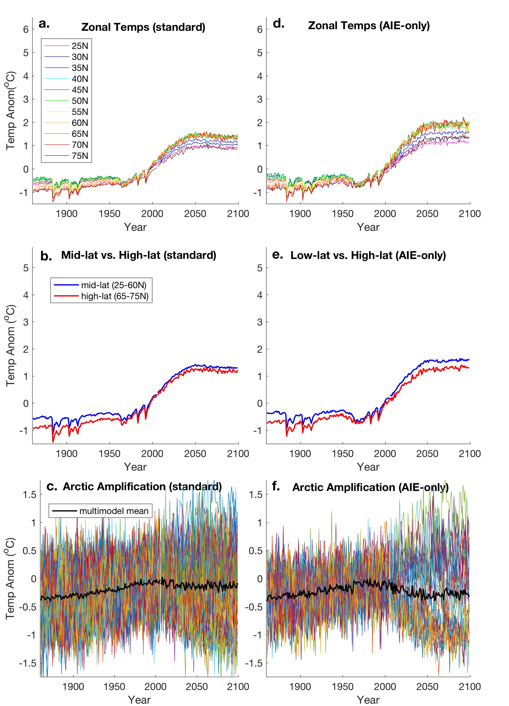

Figure S2. As Fig. 3 of main article but for RCP 2.6 CMIP5 simulations.

Figure S3. As Fig. 5 of main article but for RCP 2.6 CMIP5 simulations.

Figure S4. QRA Fingerprint based on first half (1979-1997) and second half (1998-2015) of ERA reanalysis period compared with full period (1979-2015).

Table S1. CMIP5 Historical Climate Model Simulations
Model | Number of Realizations | 1st and 2nd aerosol indirect effects
ACCESS1-0 | 1 | 1
ACCESS1-3 | 3 | 1
bcc-csm1-1 | 3 | 0
bcc-csm1-1-m | 3 | 0
BNU-ESM | 1 | 0
CanESM2 | 5 | 0
CCSM4 | 6 | 0
CESM1-BGC | 1 | 0
CESM1-CAM5 | 3 | 1
CESM1-FASTCHEM | 3 | 0
CESM1-WACCM | 1 | 0
CMCC-CESM | 1 | 0
CMCC-CM | 1 | 0
CMCC-CMS | 1 | 0
CNRM-CM5 | 10 | 0
CNRM-CM5-2 | 1 | 0
CSIRO-Mk3-6-0 | 10 | 1
FGOALS-g2 | 4 | 1
FIO-ESM | 3 | 0
GFDL-CM2.1 | 10 | 0
GFDL-CM3 | 5 | 1
GFDL-ESM2G | 1 | 0
GFDL-ESM2M | 1 | 0
GISS-E2-H p1 | 6 | 0
GISS-E2-H p2 | 5 | 0
GISS-E2-H p3 | 6 | 0
GISS-E2-H-CC | 1 | 0
GISS-E2-R p1 | 6 | 0
GISS-E2-R p2 | 6 | 0
GISS-E2-R p3 | 6 | 0
GISS-E2-R p100 | 6 | 0
GISS-E2-R-CC | 1 | 0
HadCM3 | 10 | 0
HadGEM2-AO | 1 | 1
HadGEM2-CC | 1 | 1
HadGEM2-ES | 5 | 1
INMCM4 | 1 | 0
IPSL-CM5A-LR | 6 | 0
IPSL-CM5A-MR | 3 | 0
IPSL-CM5B-LR | 1 | 0
MIROC-ESM | 3 | 1
MIROC-ESM-CHEM | 1 | 1
MPI-ESM-LR | 2 | 0
MRI-CGCM3 p1 | 3 | 1
MRI-CGCM3 p2 | 1 | 1
MRI-ESM1 | 1 | 1
NorESM1-M | 3 | 1
NorESM1-ME | 1 | 1
Anthropogenic Only Simulation
CCSM4 p11 | 4 | –
CESM1-CAM5 p11 | 3 | –
CNRM-CM5 | 10 | –
GFDL-CM3 p2 | 3 | –
GFDL-ESM2M p2 | 1 | –
GISS-E2-H p109 | 3 | –
GISS-E2-H p309 | 3 | –
GISS-E2-R p109 | 5 | –
GISS-E2-R p309 | 5 | –
IPSL-CM5A-LR p2 | 3 | –

Table S2. CMIP5 1% / year CO₂ Simulations
Model | Realizations
ACCESS1-0 | 1
ACCESS1-3 | 1
bcc-csm1-1 | 1
CCSM4 | 2
CMCC-CM | 1
CNRM-CM5-2 | 3
CSIRO-Mk3-6-0 | 1
CanESM2 | 1
GFDL-CM3 | 1
GFDL-ESM2G | 2
GFDL-ESM2M | 2
GISS-E2-H | 3
GISS-E2-R | 3
HadGEM2-ES | 1
inmcm4 | 1
IPSL-CM5A-LR | 1
IPSL-CM5A-MR | 1
IPSL-CM5B-LR | 1
MIROC-ESM | 1
MIROC5 | 1
MPI-ESM-LR | 1
MPI-ESM-MR | 1
MPI-ESM-P | 1
MRI-CGCM3 | 1
NorESM1-ME | 1
NorESM1-M | 1

Table S3. CMIP5 RCP8.5 Future Projection Simulations
Model | Number of Realizations | 1st and 2nd aerosol indirect effects
ACCESS1-0 | 1 | 1
ACCESS1-3 | 1 | 1
bcc-csm1-1-m | 1 | 0
bcc-csm1-1 | 1 | 0
BNU-ESM | 1 | 0
CanESM2 | 5 | 0
CCSM4 | 6 | 0
CESM1-BGC | 1 | 0
CESM1-CAM5 | 2 | 1
CMCC-CESM | 1 | 0
CMCC-CM | 1 | 0
CMCC-CMS | 1 | 0
CNRM-CM5 | 5 | 0
CSIRO-Mk3-6-0 | 10 | 1
FGOALS-g2 | 1 | 1
FIO-ESM | 3 | 0
GFDL-CM3 | 1 | 1
GFDL-ESM2G | 1 | 0
GFDL-ESM2M | 1 | 0
GISS-E2-H | 2 | 0
GISS-E2-H | 1 | 0
GISS-E2-H | 1 | 0
GISS-E2-R | 2 | 0
GISS-E2-R | 1 | 0
GISS-E2-R | 1 | 0
HadGEM2-AO | 1 | 1
HadGEM2-CC | 1 | 1
HadGEM2-ES | 4 | 1
inmcm4 | 1 | 0
IPSL-CM5A-LR | 4 | 0
IPSL-CM5A-MR | 1 | 0
IPSL-CM5B-LR | 1 | 0
MIROC-ESM-CHEM | 1 | 1
MIROC-ESM | 1 | 1
MPI-ESM-LR | 2 | 0
MRI-CGCM3 | 1 | 1
MRI-ESM1 | 1 | 1
NorESM1-ME | 1 | 1
NorESM1-M | 1 | 1

Table S4. CMIP5 RCP2.6 Future Projection Simulations
Model | Number of Realizations | 1st and 2nd aerosol indirect effects
bcc-csm1-1-m | 1 | 0
bcc-csm1-1 | 1 | 0
BNU-ESM | 1 | 0
CanESM2 | 5 | 0
CCSM4 | 6 | 0
CESM1-CAM5 | 3 | 1
CNRM-CM5 | 1 | 0
CSIRO-Mk3-6-0 | 10 | 1
FGOALS-g2 | 1 | 1
FIO-ESM | 3 | 0
GFDL-CM3 | 1 | 1
GFDL-ESM2G | 1 | 0
GFDL-ESM2M | 1 | 0
GISS-E2-H | 1 | 0
GISS-E2-H | 1 | 0
GISS-E2-H | 1 | 0
GISS-E2-R | 1 | 0
GISS-E2-R | 1 | 0
GISS-E2-R | 1 | 0
HadGEM2-AO | 1 | 1
HadGEM2-ES | 4 | 1
IPSL-CM5A-LR | 4 | 0
IPSL-CM5A-MR | 1 | 0
MIROC-ESM-CHEM | 1 | 1
MIROC-ESM | 1 | 1
MPI-ESM-LR | 2 | 0
MRI-CGCM3 | 1 | 1
NorESM1-ME | 1 | 1
NorESM1-M | 1 | 1

